Asia-China-Coin-Knife Money-H4.6 R7

SHAPE \\* MERGEFORMAT 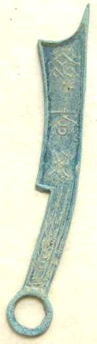

SHAPE \\* MERGEFORMAT 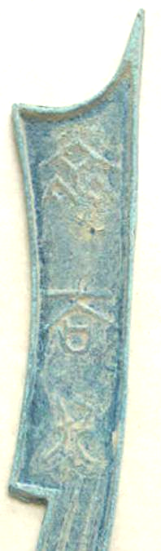 SHAPE \\* MERGEFORMAT 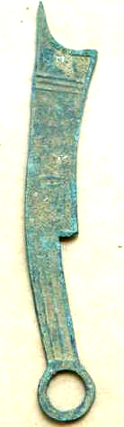

SHAPE \\* MERGEFORMAT 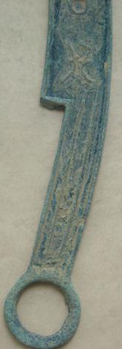

Vintage China Ancient Bronze Intermediate knife-shaped  Coin Statue

the size:17cm X2.5cm, The weight：35g